

# South Northants Link

Project Report

**Contents**

1. Why Northamptonshire needs it.
   1. Non-stop on the existing lines
   2. To improve its economy
   3. To improve its infrastructure
   4. To reconnect nearby towns
   5. To reconnect the surrounding counties
   6. A link to the West Coast Main Line
2. The route
   1. What is in the way of infrastructure
   2. Central branch
   3. Northern branch
   4. Southern branch
3. Stations
   1. Northampton Central
   2. Northampton Parkway
   3. Weedon Interchange
   4. Daventry
   5. Southam
   6. Leamington Spa
   7. Towcester
   8. South Northants Parkway
   9. Brackley
   10. Banbury
4. Services/rolling stock
   1. Service frequency
   2. Rolling stock
   3. Special services
   4. Request stops
5. Environment
   1. Getting cars off the road
   2. The UK’s net-zero 2050 promise



# Why Northamptonshire needs it

## 1a: Non-stop on the existing lines

Now, most of Northamptonshire’s railway lines are Intercity based, such as the West Coast Main Line, Chiltern Main Line and Midland Main Line, only a handful of our lines allow stopping services without causing disruption, and even these stations on these lines are rare in Northamptonshire.

Building a line dedicated to stopping services would be a game-changer in Northamptonshire, especially in Daventry and South Northants, where there are only 2 train stations across the two districts, that is one each. Allowing space on the line (not building too many stations) would also allow expansion in the future and allow new settlements to be built on the route and stations to be opened, such as in Ebbsfleet Valley and Swanscombe in the South East of the UK. These days, places need to have sustainable transport at the forefront of building new settlements, instead of having it as an afterthought. As well as this, building a separate line would mean even if trains stop tens of times, it will not clog up the entire system, unlike the West Coast Main Line, where there are no stations in the Northamptonshire area. This is the issue with the Weedon Station Project now, congestion all the way along the line. This issue would be eliminated with this new line.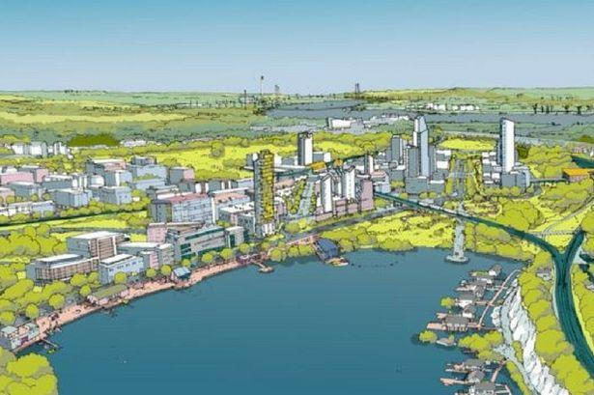

Adding to this, if something went wrong on the line such as a signalling failure, it would not affect the network nationally, only on a local level through 3 districts.

## 1b: To improve its economy

This project would be a massive win for the economy in Northamptonshire, especially in rural areas which would finally get a link to a railway line, and therefore a link to London, Birmingham, Liverpool and more.

It would mean more people can go out and get a job in a city, while staying local to Northamptonshire, while still paying taxes in Northamptonshire, and coming home with a massive paycheck from massive cities to spend on ourlocal goods, to improve oureconomy.

As well as this, people can live in small villages such as Whittlebury and Silverstone, while working in Northampton, Daventry, Weedon and others. This line is not just a win for the county and Intercity commuters, but also people who live andwork in the county, with better connectivity, they can do their job better.

As West Northamptonshire Council hears of these economic jumps, they will start investing this new-found money into more rail projects, multiplying this effect, and no longer making Northamptonshire well known for its frankly terrible rail links, and instead a popular, interesting, well connected mega-county.

## 1c: To improve its infrastructure

As everyone knows, Northamptonshire is not the best when it comes to transport links, especially via rail. Only 6 train stations exist in Northamptonshire, and more than 50 were closed in the 1960’s by British Rail during the Beeching Era, after he suggested closing certain lines. The only stations that exist now are:

* Northampton
* Long Buckby
* Corby
* Wellingborough
* Kettering
* Kings Sutton

These stations are not enough for the growth happening in Northamptonshire, and Northampton itself. Northampton is not even on a main line, instead, just on a branch of the WCML, which makes trips to London unnecessarily longer. Northampton’s closest connection to the Central West Coast Main Line is a 25-minute drive to Milton Keynes Central, although the main WCML itself is almost viewable from South Northampton.

To deal with this issue, more money needs to be invested in the rail network, such as building new lines, and building new stations. Not only will the rural parts of Northamptonshire benefit from this, but also Northampton, Banbury, and other large towns on the route. This is a massive win for everyone, especially Northamptonshire, but also Warwickshire and Oxfordshire, the counties that surround Northants.

Northamptonshire County Council only have a department called Northamptonshire Highways, which shows Northamptonshire cares more about their road than their rail, or even public transport in general.

## 1d: To reconnect nearby towns

The primary focus of this project is to connect some of the nation’s largest towns without a National Rail link, so here is how we plan to do that with this project. The project will reconnect Brackley, Towcester, Daventry and even Southam to the National Rail network. All some of the largest towns without a National Rail link. It will also reconnect Weedon and West Northampton to the network, as well as Towcester suburbs such as Silverstone and Whittlebury with one of our main flagship stations, South Northants Parkway.

London will only be a half-hour train from Weedon Interchange, so more people can live in towns such as Towcester and Daventry, and commute to London with ease, with a simple connection at Weedon Interchange. In the future, these towns could get an even better connection, because as they grow, more rail attention will be on them, and more stations such as Parkway stations can be built, or their existing station could be modernized or improved, such as better bus links or lengthened platforms for newer rolling stock.

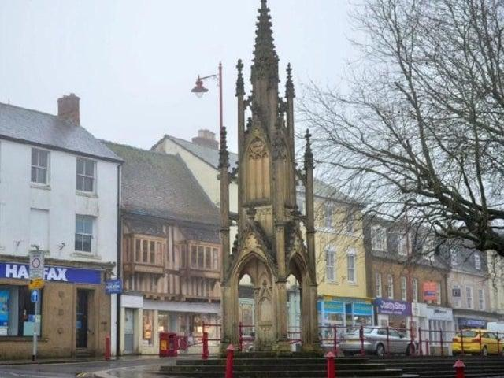

With this new-found reconnection, people can start working further away, within the county and in neighbouring county towns such as Banbury. This will improve the economy, but also attract more people to these beautiful towns and villages in the heart of the United Kingdom, as well as turn Northampton into an even better place, transforming the city centre, their high street, and of course, their transport scene. And allowing more efficient travelling to the city from other rural areas in the county.

We cannot finish this document without mentioning Northampton’s high street. There is nothing to attract it with, and instead, people are shopping in retail parks, and not on Northampton’s high street, which has the potential to be one of the country’s best city high streets, but that potential cannot be unleashed without this new transport link.

## 1e: To reconnect the surrounding counties

Of course, our primary focus continues to be locally within Northamptonshire, but with this project also comes a great opportunity: Link Northampton to Banbury and the Chiltern Railway Network.

This will be the main benefit for Northampton, to get a link to one of the hardest to access places via rail from Northamptonshire, Banbury, and the rest of the Chiltern Railways Network, such as Aylesbury and Oxford, which are also hard to access via rail from Northamptonshire, requiring multiple changes, including sometimes all the way down in London.

As well as this, a direct link to Leamington Spa will also be created, on the Northern Branch of the line, so people on this branch such as in Daventry, Southam and of course, Northampton, can directly access Leamington Spa, an amazing town, which deserves links to Northampton, Southam and even Daventry.

Having a connection to Banbury and Leamington Spa does not mean *only* Banbury and Leamington Spa, it also means connections to other Chiltern Main Line served areas, such as Oxford and Aylesbury. This would boost the economy and allow students to study and get well-paying jobs in Oxford, while living in Northamptonshire.

## 1f: A link to the West Coast Main Line

Weedon Interchange will be one of the most important stations on the network for several reasons. It allows people to change from the Southern to Northern branches and vice-versa, but most importantly, gives passengers access to the West Coast Main Line, arguably the most important railway line in the United Kingdom.

If the right operators stop at Weedon Interchange, it could introduce direct services as far as Glasgow and Edinburgh, but as close as London and Birmingham. The most likely thing to happen is London Northwestern Railway to stop at the station, who also happens to be the operator of the entire South Northants Link Line. However, Avanti West Coast, the “high-speed” Intercity operator may also stop at the station, for the one benefit that they will be able to connect Northamptonshire, not just the village of Weedon. If Avanti West Coast does stop at the station, it would mean fast services to and from Northamptonshire to places as far North as Edinburgh and Glasgow. If London Northwestern stops only, services will not go more North than Liverpool Lime Street, and more South than London Euston.

It is not only Towcester, Northampton, Weedon Village and more that could access the West Coast Main Line, but also Banbury and Leamington Spa, with simple access to one of the busiest railway lines in the world, and a first for these two towns, almost direct services to cities as North as Crewe and Liverpool, and maybe even Scotland.



# The route

Note: The route is downloadable from our website, updated every week.

## 2a: What is in the way of infrastructure

Recently, I have finished a possible route between Northampton and Banbury/Leamington Spa, which includes removing around 4 living accommodations and 2 farms, and around 30 fields. However, most of the proposal follows existing infrastructure such as Motorways and Dual carriageways, so no more destruction will be needed on these parts of the line.

This page is in progress.

## 2b: Central branch

The Central branch is the route between Northampton Central and Weedon Interchange, with only one station on the route, Northampton Parkway, located in Upton

Notable areas which will be in the way of infrastructure include Upton Country Park, on the Central branch, but this can be avoided with a long viaduct, which will also maintain the greenery of the area.

The Central branch goes through the following settlements:

* West Northampton
* Upton
* Upper Heyford
* Weedon
* Flore

Out of all the South Northants Link branches, this is the one that will cause the least disruption. When the branch is being built, however, many bridges will have to be built, one of these being the M1, the second busiest M-road in the country. Below, a figure shows the route that the line takes, above a roundabout to divert onto A-roads from the M1.

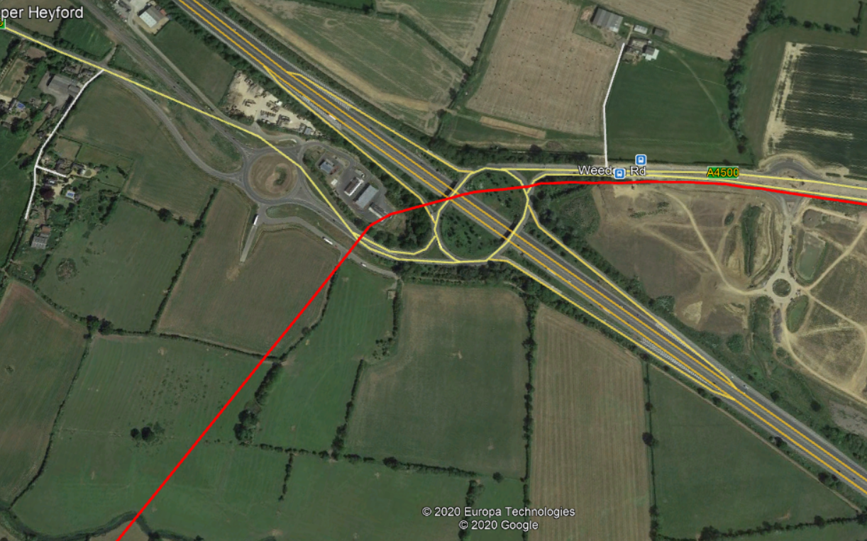

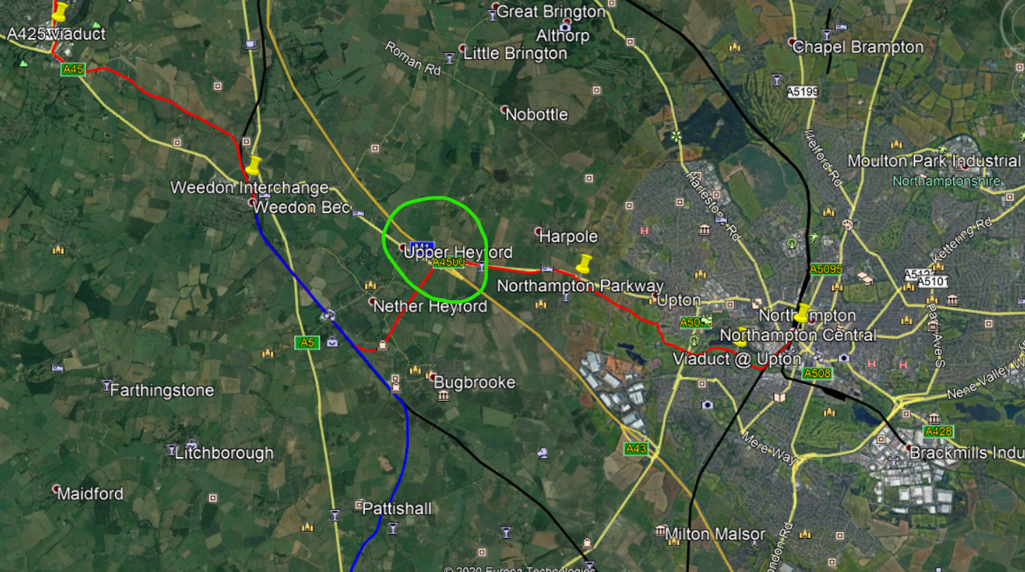

Approximately 3 bridges will have to be built above this specific bit of road, and this will no lie cause disruption for the motorway network, but a similar infrastructure project, High Speed Two, are using a modular bridge design, which is manufactured off premises, and “placed” above the road, causing minimal disruption. This process has taken HS2 Ltd around 1 day in total, in Solihull. This means that for that 24 hours, commuters could instead use other routes as the replacement to that specific part of their journey.

The Central branch is vital to the success of the South Northants Link project, and luckily for us, the branch that will be simplest out of all three of them. Phase A of the project includes the construction of this branch, and includes the following tasks as well:

* Upgrades to Northampton Central to increase capacity.
  + Works to improve accessibility
  + Adding 2 extra platforms
  + Extra taxi lanes
  + Renaming the station
* Construction of Northampton Parkway
* Construction of Weedon Interchange
* Works on stopping services from the WCML at Weedon Interchange

## 2c: Northern branch

The Northern branch links Daventry, the largest town in the UK without a railway station, to the National Rail network, by implementing a direct service to Leamington Spa and Northampton Central from the brand-new Daventry station.

I am going to split this section into 4 different sub-parts

1. Weedon Interchange to Daventry
2. Daventry to Southam
3. Joining the Chiltern Main Line
4. CML to Leamington Spa

Starting with Weedon Interchange to Daventry, the most straightforward and simple section on maybe the entire link. To start, the route leaves Weedon Interchange station going Northbound, continuing the WCML until it gets too East Dodford, where it junctions off and starts its own line as seen in the figures:

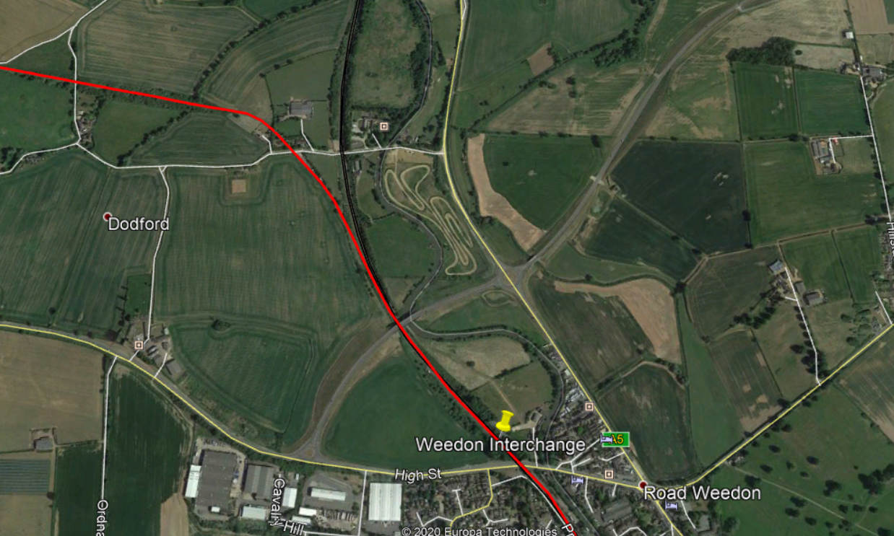

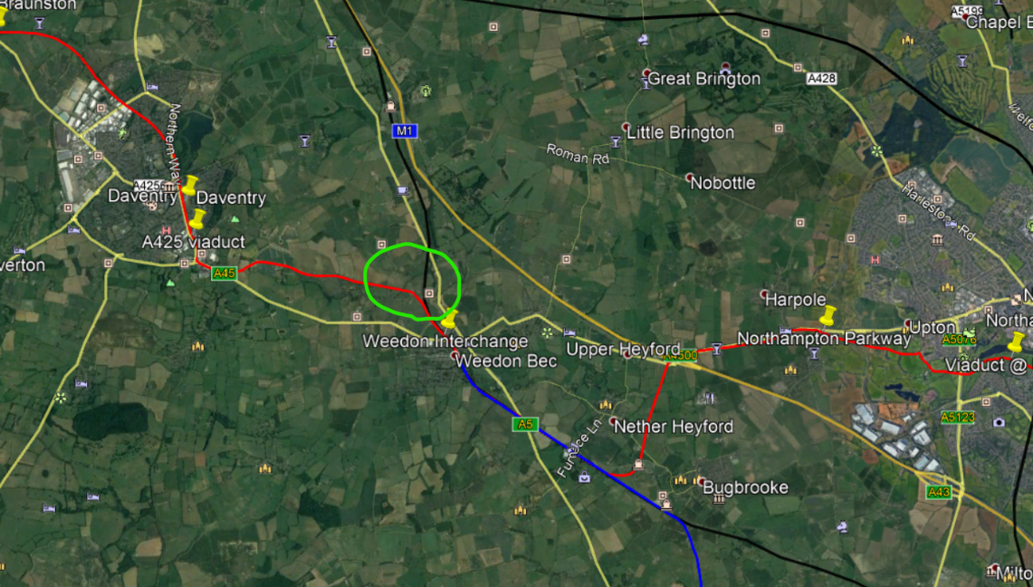

Most of the route to Daventry, it then stays in between the trees between farmers’ fields and other land, however, after some research, part of the route is a path used by farmers to get to their field. A deal will have to be made with the farmers to somehow get permission to 1) allow access to their land and 2) allow access to remove their roads. The contractors could even offer to relocate their dirt paths somewhere else, that could be part of the deal. You can see the small issue in more detail in the figure below:

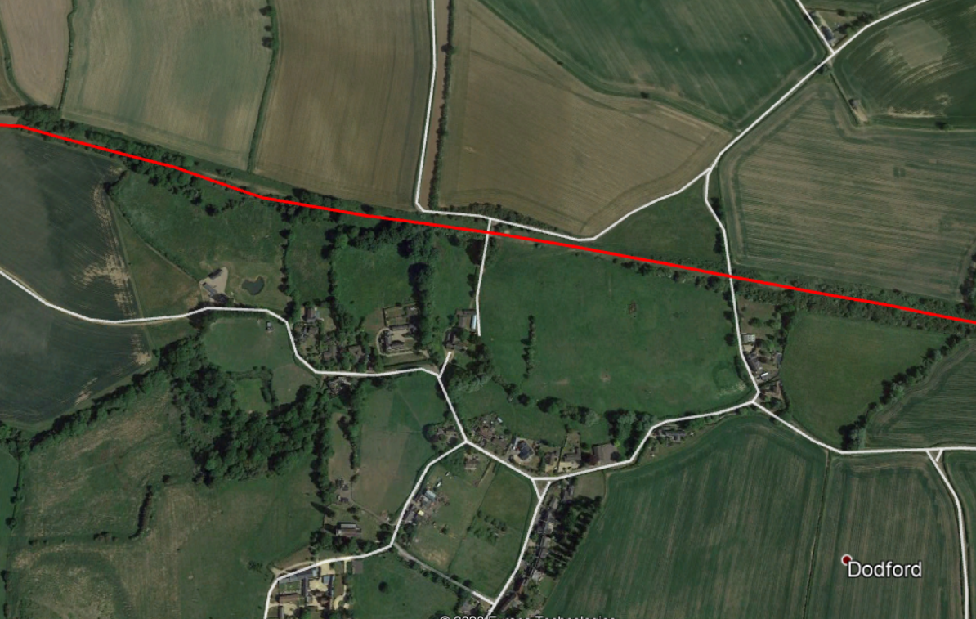

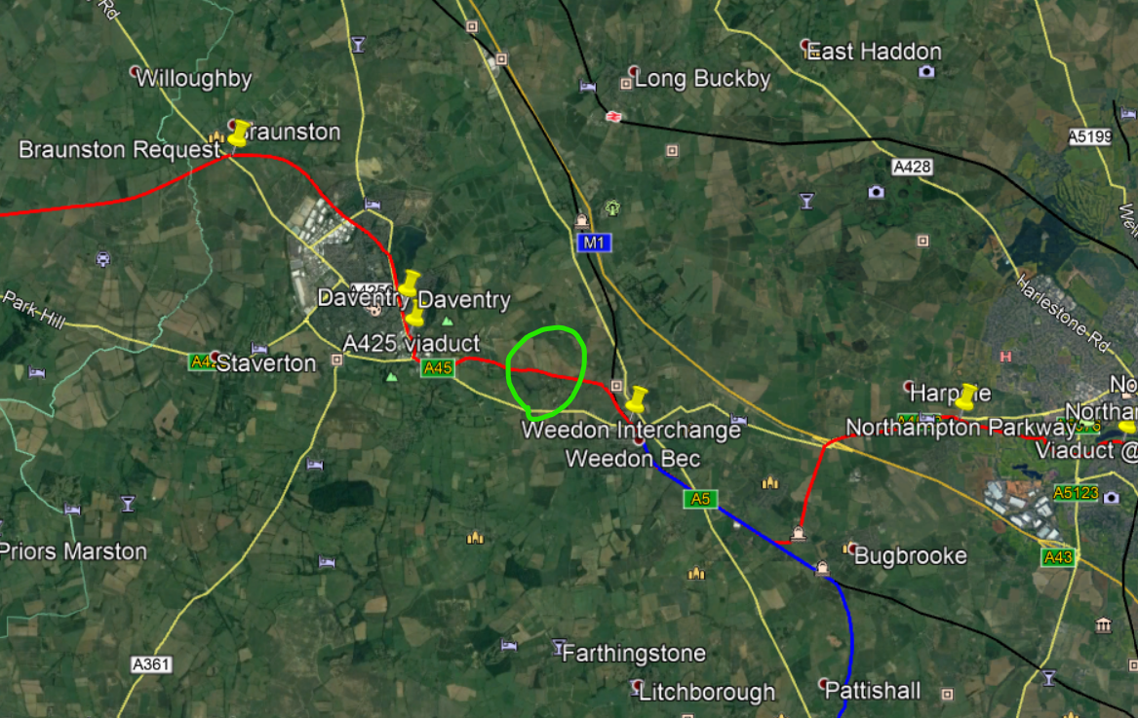

At the end of the fields, the line follows the A45 for around 1.1 miles, which includes going through a business park, but this will not destroy any buildings on the route, see the figure on the next page for details:

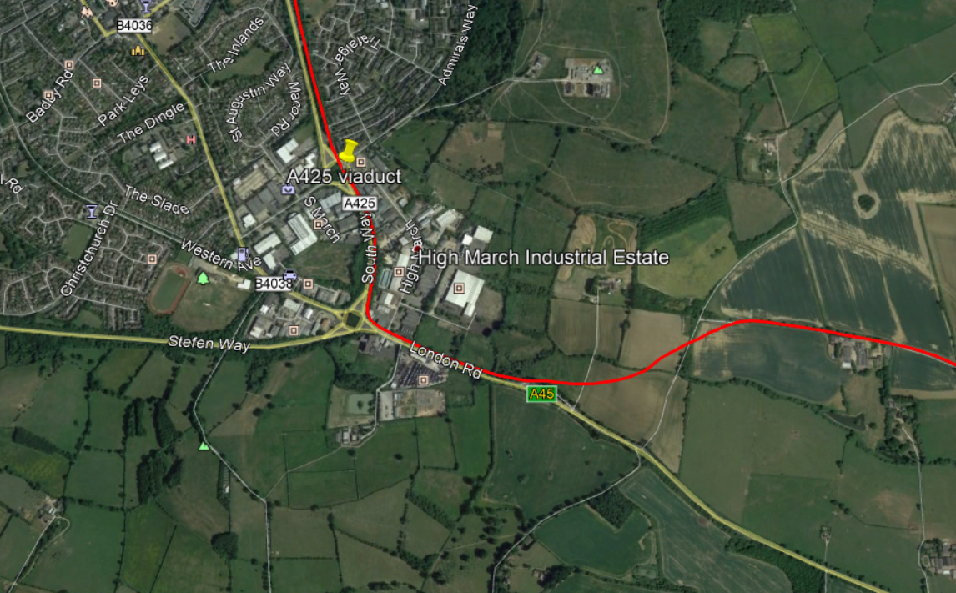

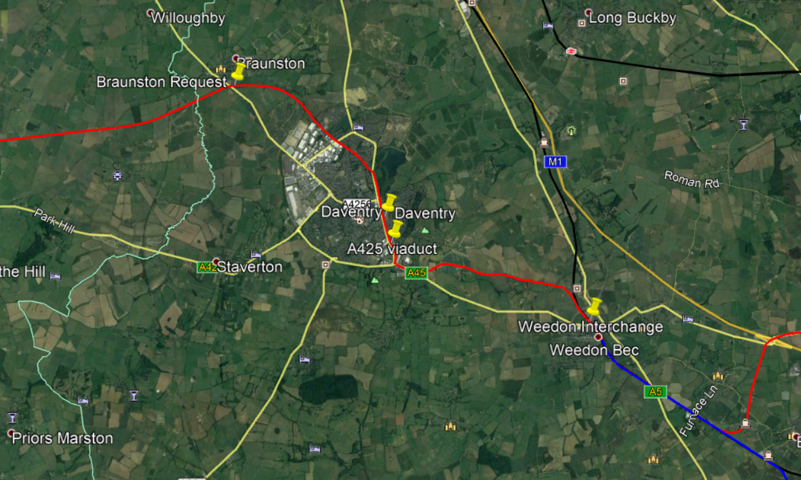

The line then pulls into Daventry station, which is located right opposite McDonald’s Daventry and a petrol station, on empty land, perfect for a railway station to be located. This is where this section terminates, the next section is Daventry to Southam, which I will cover now.

The Daventry to Southam branch is quite a complicated one, as it requires a lot of bridges to be constructed.

The route continues in-between trees, to reduce damage to farms and fields. Many railway lines use this sort of tactic. However, as the line approaches Calcutt, we must cross the canal, and on the other side of the canal, the trees end, and we must continue through fields. This will cost a lot of money to buy out and make deals with farmers and landowners. An alternative could be another tunnel. The line is now approaching the town of Southam, where the line cuts through about 10% of the town to then make a turn to the South to avoid damaging the town. See the figure on the next page for some context:

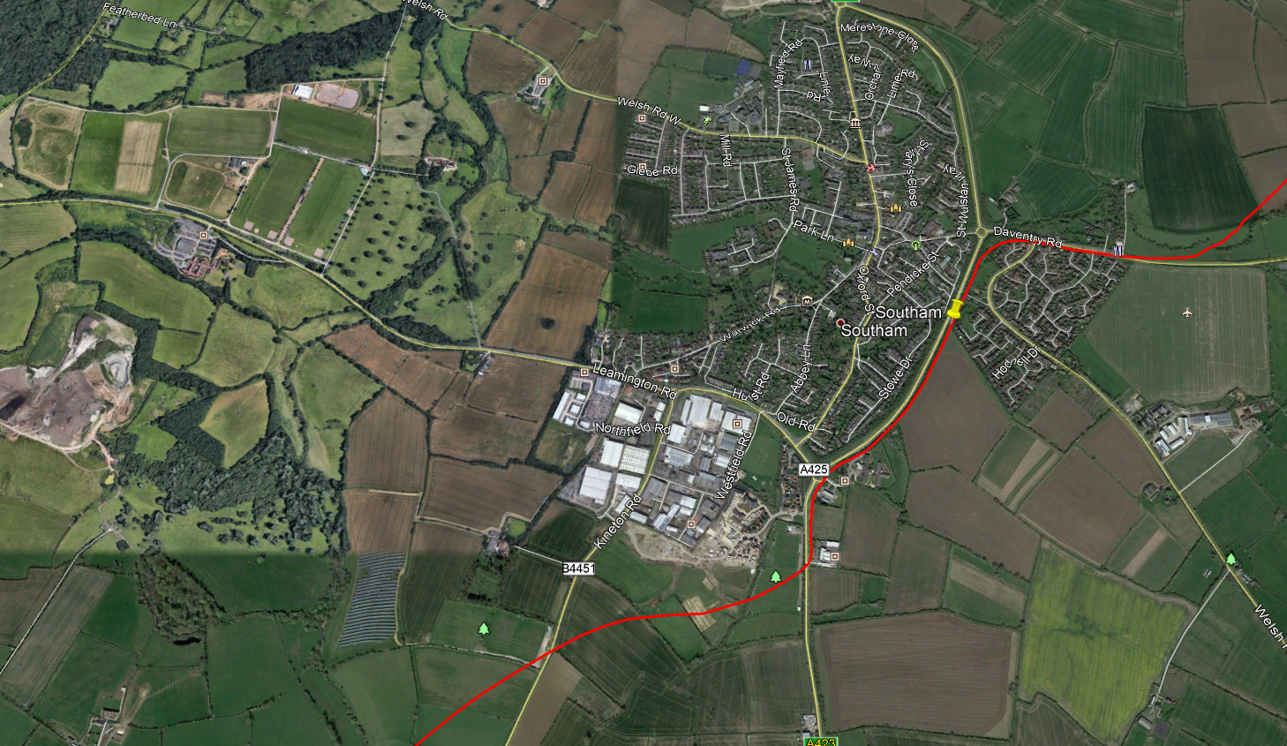

Now moving on to the next section, to link with the Chiltern Main Line. One of the most straightforward tasks. The line leaves Southam and goes in-between more trees, but then unfortunately must cross around 15 fields, this will undeniably cost a lot of money. However, after around 0.7 miles, the line links with the Chiltern Main Line. See figure below:

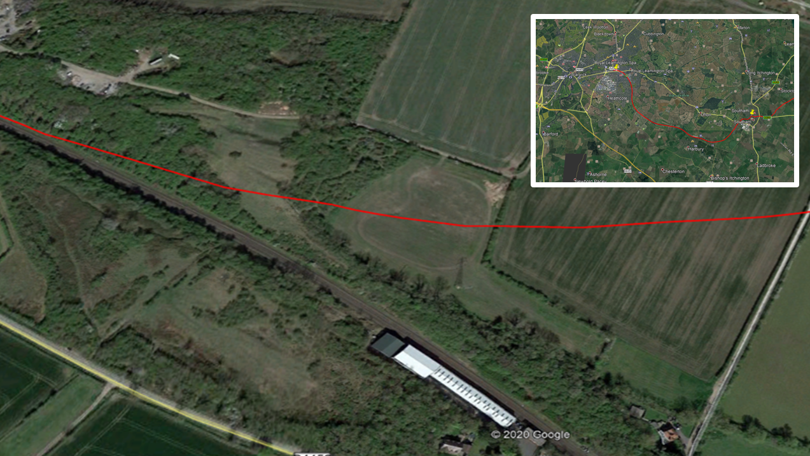

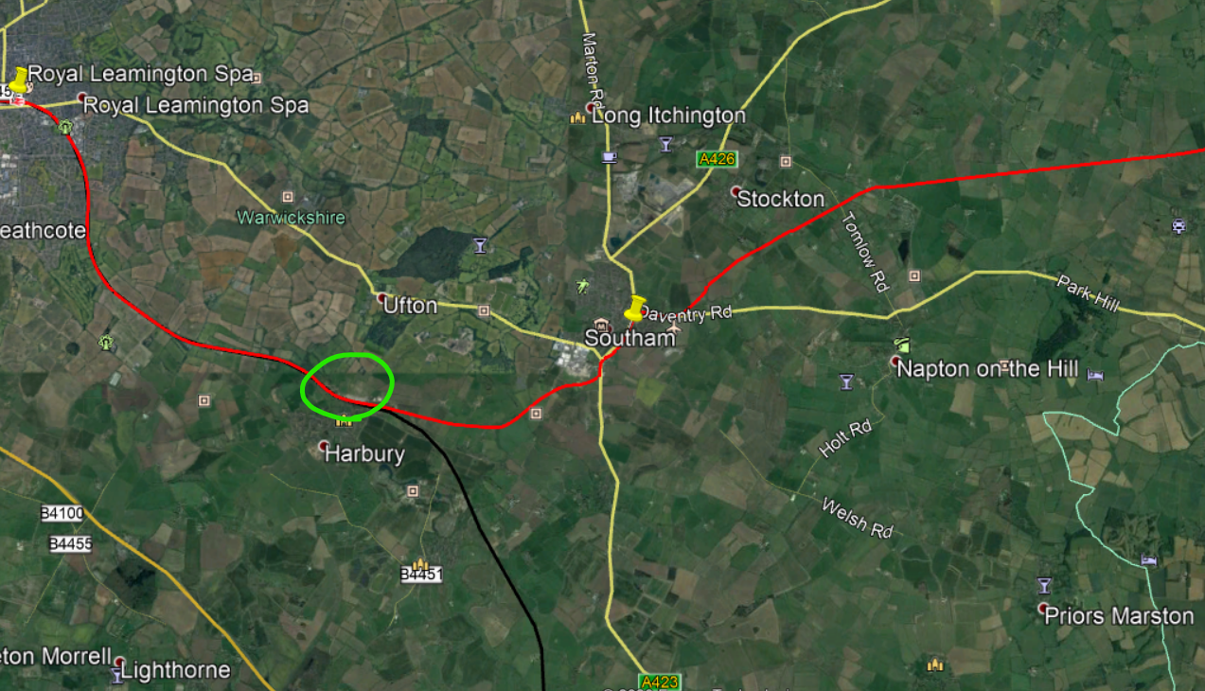

The line now essentially follows the route to Royal Leamington Spa, and then the Northern branch terminates at 2 new platforms at Leamington Spa station. No more explaining is needed, I do not think. People can then change onto Chiltern Railways, West Midlands Railway and CrossCountry services on the Chiltern Main Line and others.

The Northern branch terminates here.

## 2d: Southern branch

This branch is the most complicated of the lot, with the most railway stations, the most area to cross and the most complications on the route, including connecting with the Chiltern Main Line right outside Kings Sutton station, and finding space for a South Northants Parkway station. However, I have taken these challenges on and figured something out, splitting it into a few parts to explain efficiently:

1. Weedon Interchange to Towcester
2. Towcester to Brackley via SNP
3. Connecting to the Chiltern Main Line
4. Route to Banbury

To start, we need to go all the way back to Weedon Interchange, and instead go South, continuing the West Coast Main Line for around 3.3 miles, then splitting off right outside Bugbrooke, then cutting through a few fields, to follow the A5 for the remainder of the trip, see figure:

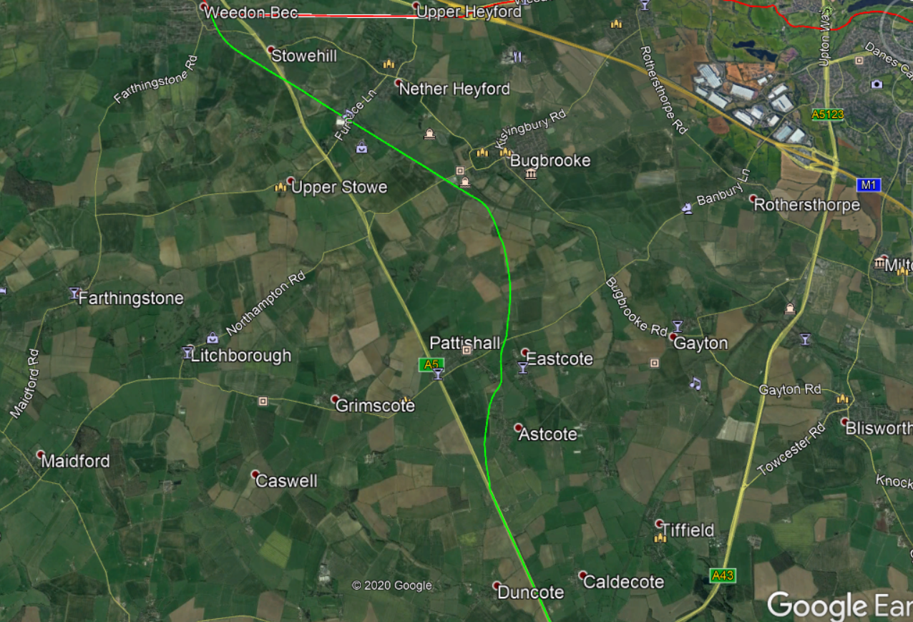

After travelling 1.7 miles down the A5, the line reaches Towcester station, which is proposed to be located right opposite Tesco Towcester, or next to the A43 on the West. A bridge will be required to cross the A5 to access Towcester station.

The line now leaves Towcester, on-route for Brackley, while going through South Northants Parkway, located right outside the Silverstone Circuit. The line follows the A43 for this trip, therefore not requiring going through or destroying any fields or living accommodation. After around 2 miles, the line arrives at South Northants Parkway, which will get a special service for the Silverstone Circuit, see figure below:

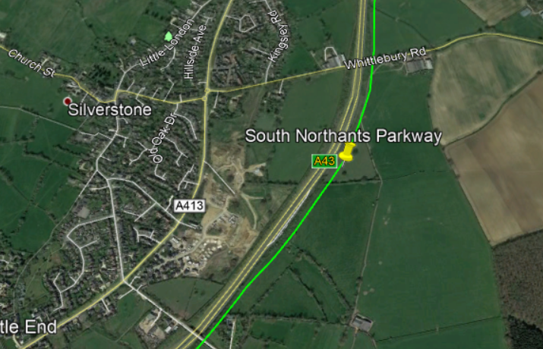

From here, the circuit is around a 15-minute walk, and this station will be especially useful for Silverstone Village and Whittlebury, which is opposite Silverstone, and can be accessed via Whittlebury Road, visible on the figure. The line now continues to Brackley, which is approximately 6 miles away.

During this period, the line continues to follow the A43, therefore not destroying any infrastructure. After travelling alongside the A43, the line pulls into Brackley station, the 13,000 populous town which hasn’t had a train station since the 1960’s. See figure below:

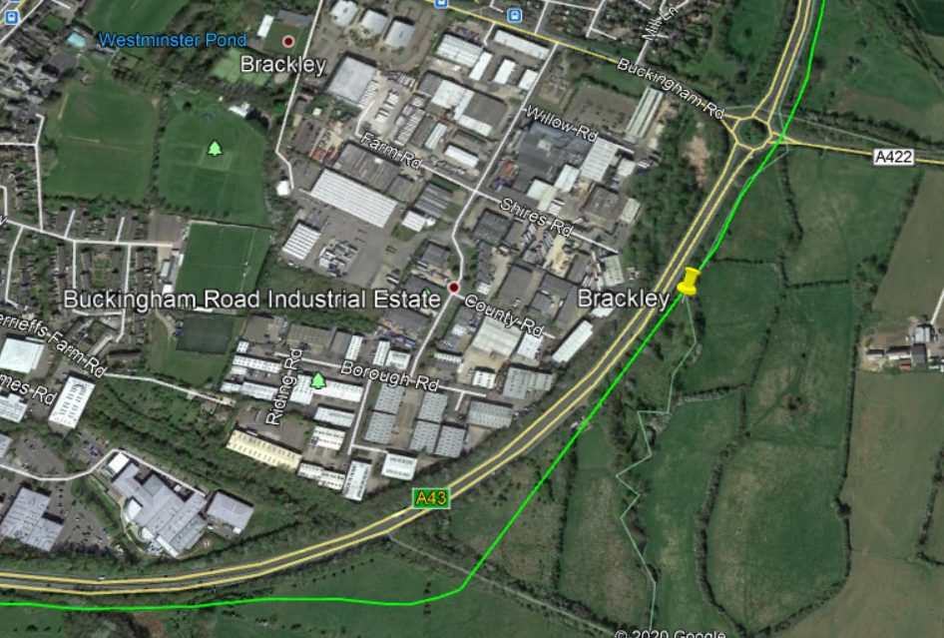

The line now continues through the old alignment from Brackley to Banbury, which means no destruction except half a pond in a farm on the old alignment, and a few bridges, including above the M40. After following the line for some time, it runs into Banbury, where it terminates in its 2 new platforms.



# Stations

## 3a: Northampton Central

The original station, Northampton, but with a new name to match its brand-new sibling, Northampton Parkway. A few upgrades will be needed at Northampton Central, including the following:

* Two new platforms to be built, to handle the new line.
* All platforms to be made more accessible.
* More Taxi lanes for more usage.
* Renaming the station.

As the hub station, with all services on the Northern, Southern and Central branches calling there, it needs to be ready for a lot of traffic. With these upgrades, we are sure Northampton Central can handle it, with Northampton Parkway there if it gets too busy. People can take a SNL train to Northampton Central and catch a London Northwestern Railway WCML service to London/Crewe from this station.

There is not much else to say about Northampton Central, but we know this new line would change not only the station, but the rest of Northampton forever.

## 3b: Northampton Parkway

One of the most important stations on the network, acting as a buffer for Northampton Central if it gets too congested, and acting as Upton and West Northampton’s link to the railway.

The station design will be like other parkway stations in large towns such as Aylesbury Vale Parkway, see the figure below:

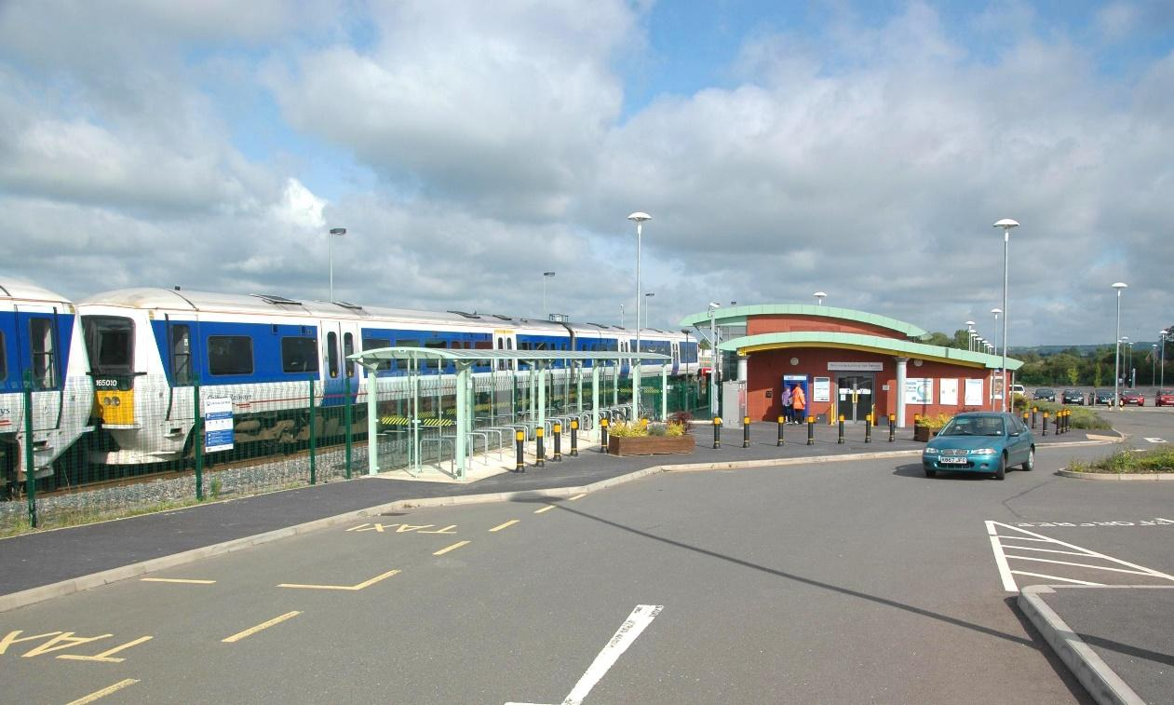

The station will have a large car park, with a small but respectable station building. The station will have 2 platforms, extendable to 4 in the future if capacity requires. It will be located just outside Upton right off an A4500 roundabout, see figure on the next page:

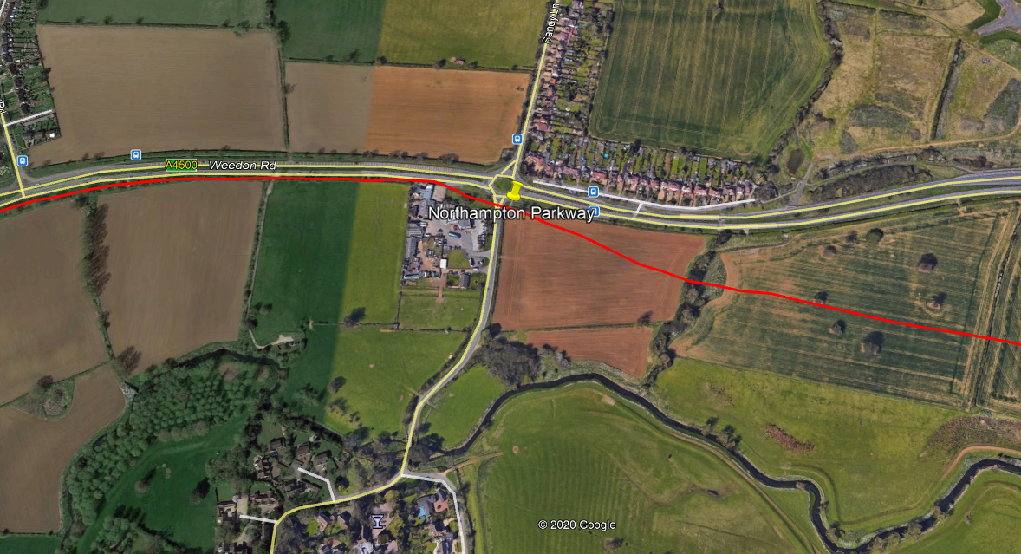

No other rail links will be available at the station; however, bus services are available at nearby bus stops, which will be assigned for station use. The main purpose of the station as I said, is to take congestion off Northampton Central, but to also serve West Northampton and the suburbs of Northampton.

Upton is becoming a busy place, and so is Harpole, both examples of villages/suburbs in West Northampton. They need a sustainable rail link, and this is how we will achieve it. No special services will stop at the station, including Silverstone Race services, due to the niche nature of such a service stopping at the station. However, exceptions include if Northampton Central is too congested. However, all standard timetabled services will stop at the station. See figure on the next page for precise location:

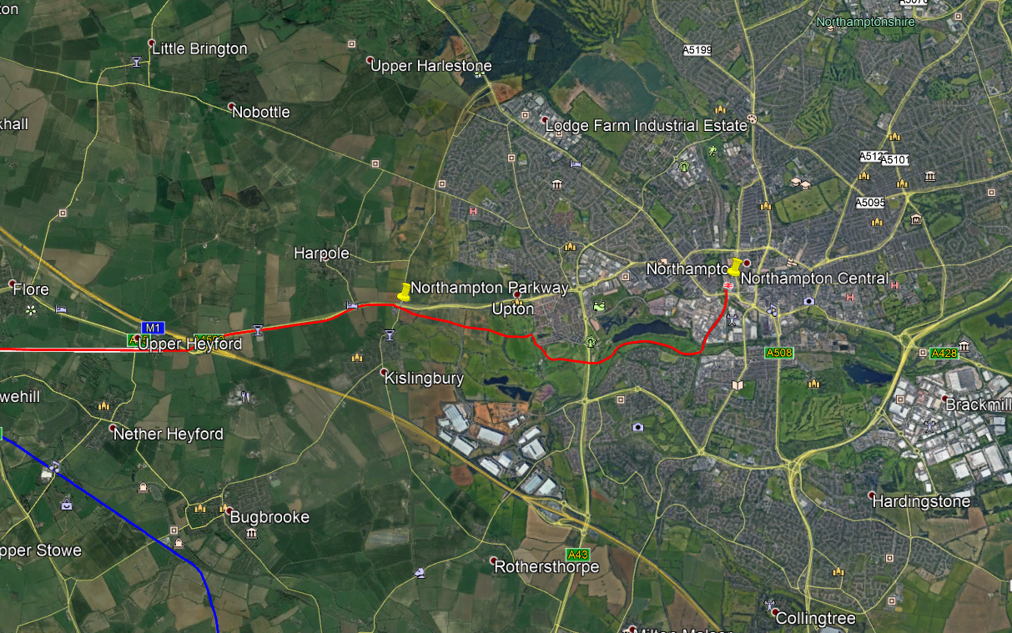

## 3c: Weedon Interchange

Weedon Interchange is the main station on the South Northants Link network, connecting the Central, Northern and Southern branches to the West Coast Main Line.

The design of the station and size will be relatively similar of Ebbsfleet International, a Highspeed station in the South East of England, see the figure below:

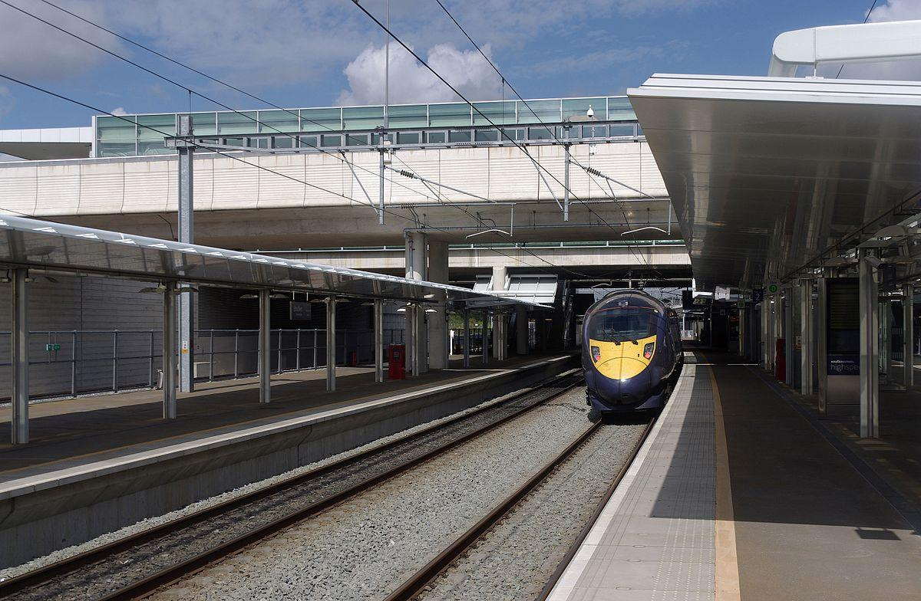

6 platforms will be in use at Weedon Interchange, 2 for stopping WCML services, 2 for non-stopping WCML services, and of course, the South Northants Line services, of which all will stop at the station, including special services. A car park will be in place at this mega-station, located either on a nearby field, or in the Heart of England pub. Buses will also have a connection to the station, with existing bus stops in the area.

The location of the station will be in the existing area of the proposed Weedon Station by sister project, Weedon Station Project, see the figure below:

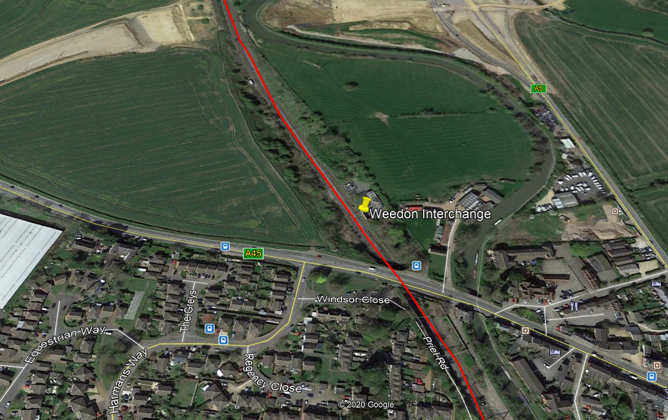

Land will have to be purchased to the West of the line, for space for the station building, a car park, and other platforms, as the East of the line has been purchased for building a new housing estate, from which will benefit from this station.

Weedon is growing at a rapid pace, and needs a connection to the National Rail network, with new infrastructure and housing projects happening in the area, and the population growing rapidly. All South Northants Link services will stop at the station, with a half-hourly London Northwestern Railway service stopping at the station, and if the operator agrees, an hourly Avanti West Coast service stopping at the station, North, and South.

## 3d: Daventry

Daventry has been disconnected from the rail network since the 1900s and is one of the largest towns in the UK not to have a railway station. As Daventry is the 6th largest town in Northamptonshire, and the second most important town in the county, according to the new Unitary, it deserves to have a large station too. Daventry’s station size and design will be comparable to Herne Bay, in the South East, see figure below:

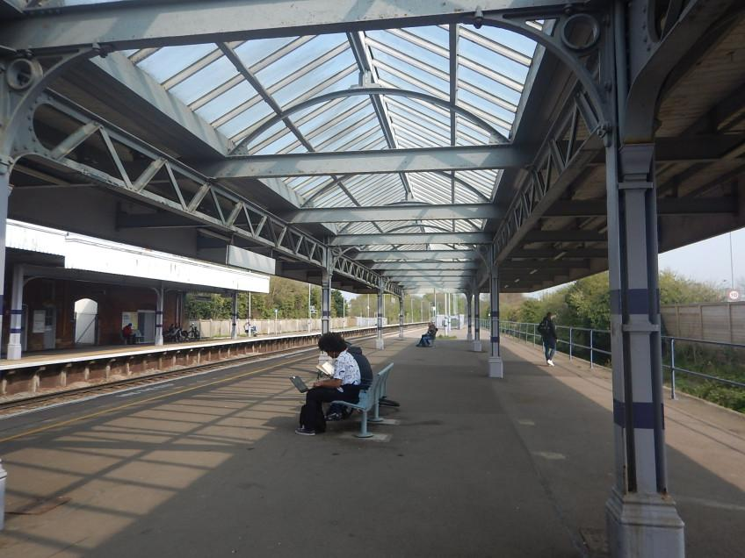

The station will have 2 platforms, extendable to 4 if capacity requires. It will be located opposite McDonalds Daventry, on the A425. It will have a large car park, which could have the potential to have two stories. There is a large unoccupied field which the station will be built on, so space is not a problem, see figure on the next page:

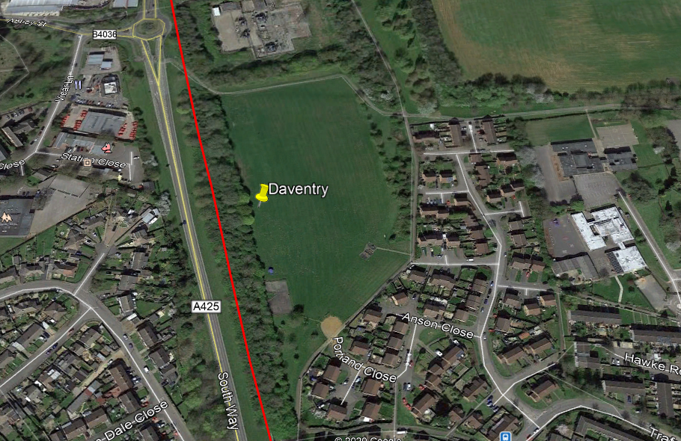

No other rail links will be available at the station; however, bus stops can be added to the station concourse, which will house the car park, ticket machines, and of course, bus lanes. No bus stops are currently available near the proposed station location.

All services will stop at the station, as no special services will run on the Northern branch line. Daventry are in dire need of a new rail link, and this will be their big break, being able to get to London in approximately an hour, by changing at Weedon Interchange for a West Coast Main Line service.

## 3e: Southam

While I write this document, Southam is being heavily impacted by rail lines, such as the Chiltern Main Line on the outskirts, and HS2 going right through the town. Obviously, this proposal does not want to make it worse, but instead give back to the town, as even with all these railway lines, Southam does not have a railway station.

Southam’s station will be relatively small and unmanned, but with a unique design, somewhat like Barnstaple in the South West, see figure below:

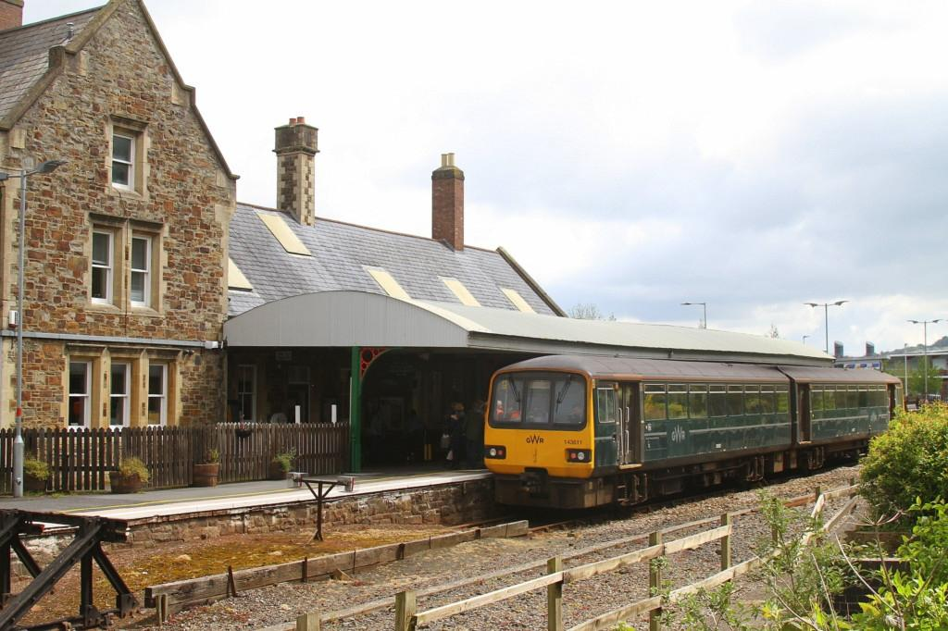

Unlike Barnstaple, the station will have 2 platforms, unlikely to be extended to 4 though, as usage of the station is expected to be low. A small car park, with around 8 spaces, which is standard for small stations such as Kings Sutton, will be installed, including accessible parking spots. Now, no bus stops are available at the station location, so new bus stops will have to be installed on the station concourse/car park.

The station will be located on the outskirts of the town, in the East. It will only encroach on 10% of the town.

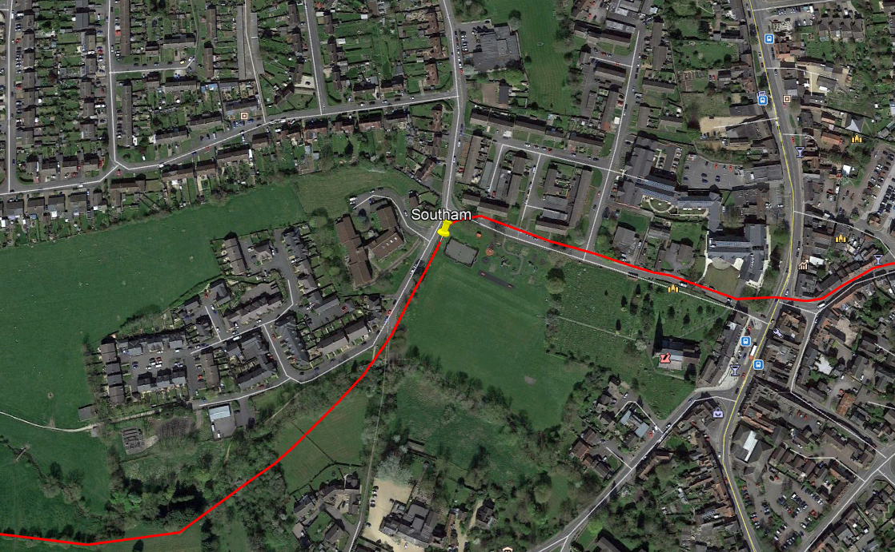

The purpose of this specific station is to give Southam, a busy town, that is growing, a link to the National Rail network, being only two stops from access to the Chiltern Main Line at Leamington Spa.

Around 75% of services will stop at the station, and all rush-hour services. No special services will stop at the station, as this is not required on the Northern branch. A station building may be implemented, but no promises are being made.

## 3f: Leamington Spa

Leamington Spa already have a railway station, with West Midlands Railway, CrossCountry and Chiltern Railways services calling at it, almost even 5 minutes. Of course, adding another line to the station will cause a lot of issues when it comes to congestion, so the following upgrades will have to be made:

* Two new platforms to be added to the station.
* Car park to be extended, to add more capacity.

As you can see, these upgrades are limited, but not many will have to be made, but the ones that do are big ones.

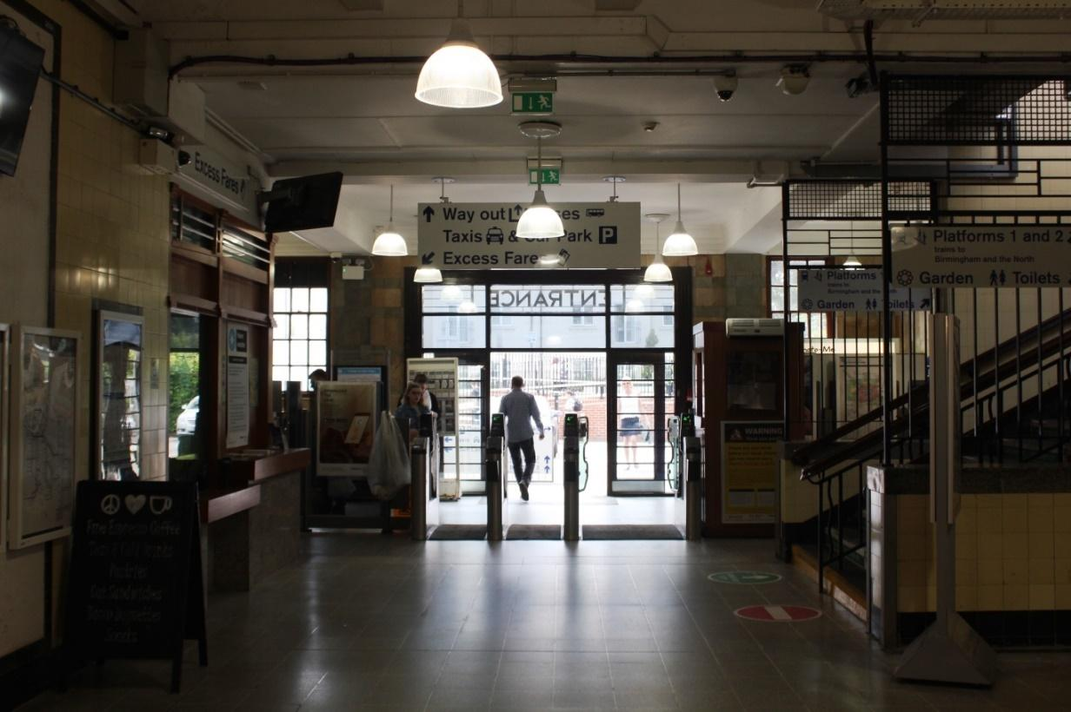

## 3g: Towcester

Now moving on to the Southern branch, Towcester has been without a rail link for around 90 years, although being the largest and busiest town in South Northamptonshire. Because of Towcester being so major in the county, it deserves one of the nicest train stations on the network. It will look something like Whitstable station, on the South Eastern Main Line, see figure below:

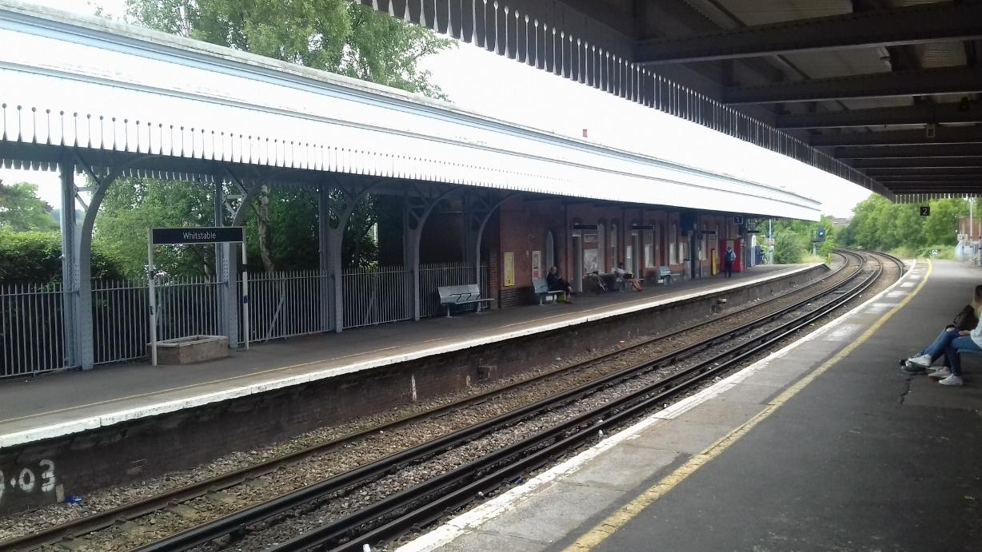

The station will have 2 platforms, extendable to 4 if capacity requires. Buses unfortunately do not currently serve the area the station would be built in, so new bus stops would have to be implemented in the concourse. Speaking of the concourse, the station will have a large car park, as there is a lot of space at the proposed location, just next to the A43, see figure on the next page:

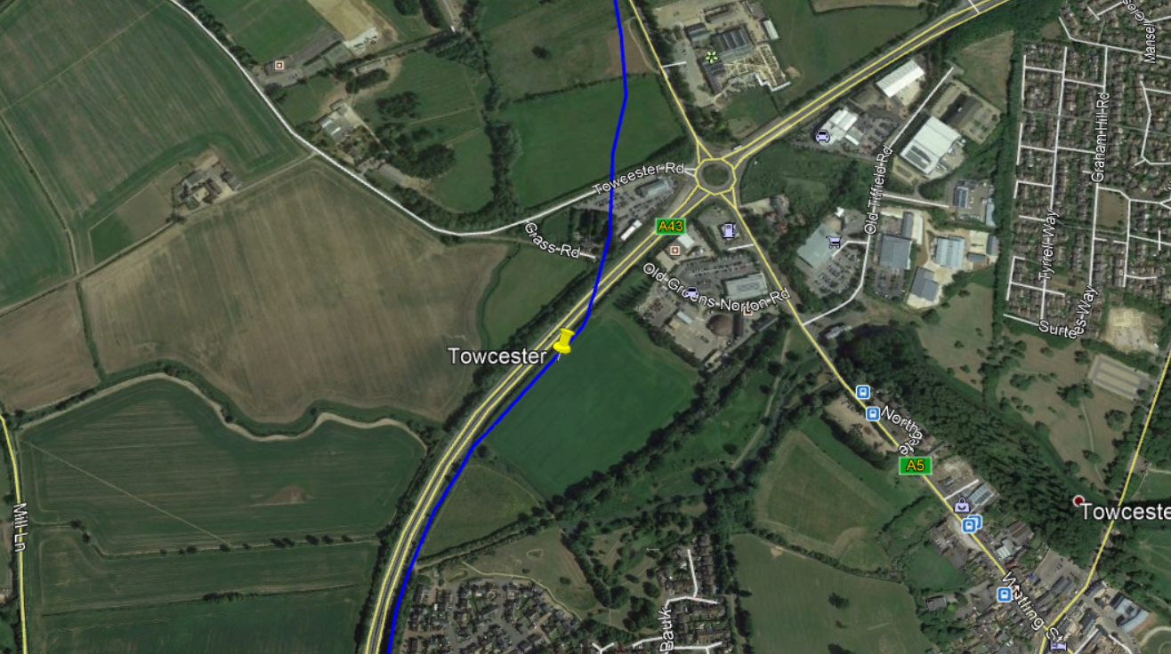

All services will stop at Towcester, including special services to South Northants Parkway. Towcester are in such a need of a link like this. The population, like all other areas on our network, is growing rapidly, and so is the need for a link like this.

## 3h: South Northants Parkway

South Northants Parkway is an interesting one, being almost in the middle of nowhere, until you turn around. Silverstone Circuit is one of the busiest race circuits in the country, and one of the most famous too. Although this is the case, it has weak transport links, like its village neighbours, Silverstone Village and Whittlebury. Therefore, it needs a connection on this new line, to bring in more visitors, not only to the circuit, but Northamptonshire itself.

The station will be quite big, like newly opened Worcestershire Parkway, see the figure below:

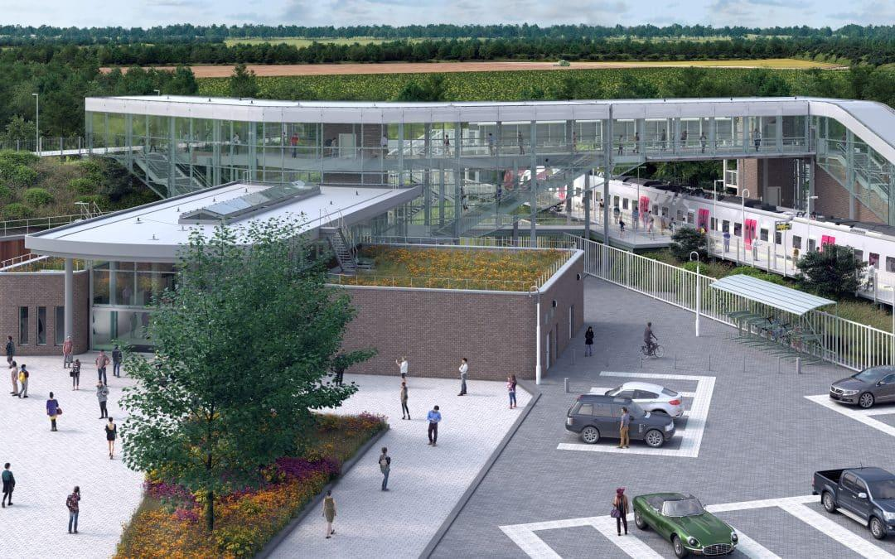

It will have 2 platforms, but unlikely to extend to 4 in the future due to expected low demand on days races are not on. However, the car park at the station will be one of the largest on our network, to enable a park-and-ride type facility. The station building will also be quite large, including a café type shop, maybe run locally by residents in the village.

Unfortunately, bus services are not currently available at the station location, but bus lanes will be installed in the concourse area, also enabling a shuttle service between the nearby circuit and the station.

The location of the station will not be far off the A43, and Silverstone Village, see figure below:

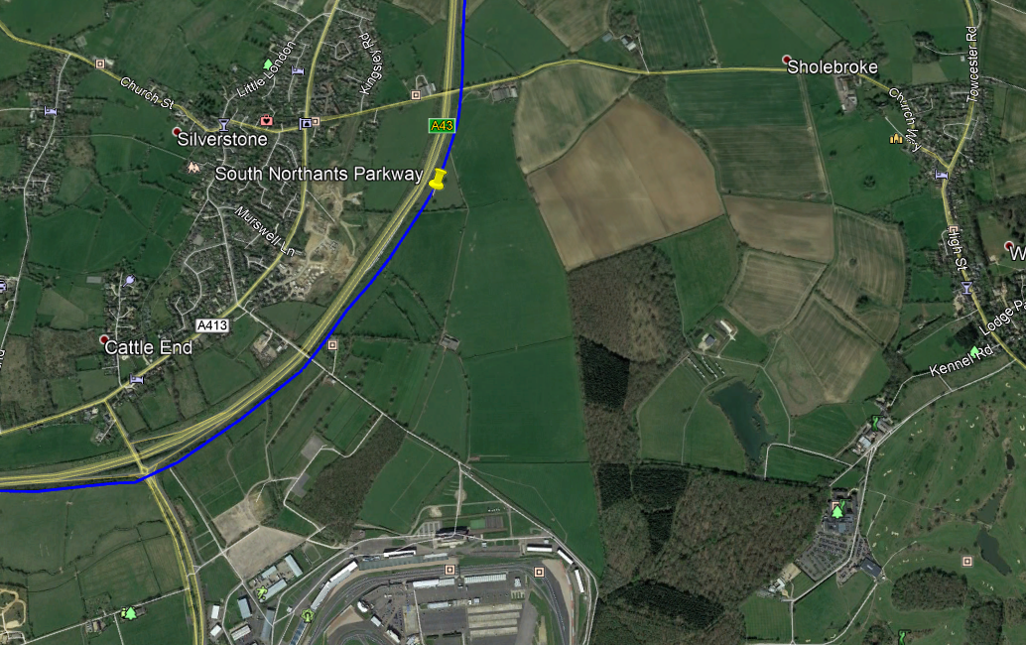

The circuit is at the bottom of the photo, and at the very right, Whittlebury, and very left, Silverstone Village. Special services will run to the station on race-days and will also include a shuttle service to the circuit if demand requires it. On standard days, around 65% of services will stop at the station, and most at rush hour for the nearby villages, so they can work in other towns

The purpose of this station is not only to enable services to the circuit, but also to enable rail links for the nearby villages such as Silverstone Village and Whittlebury, and nearby Towcester suburbs and hamlets such as Sholebroke. However, the population of the area the station will serve is only around 6000 people.

## 3i: Brackley

Brackley has the largest population of any town in South Northamptonshire (2011 census) and has got terrible public transport links. That is where South Northants Link comes in. The station will be quite small, although every service passing the station will stop. The station will resemble Smethwick Rolfe Street in West Midlands, see figure below:

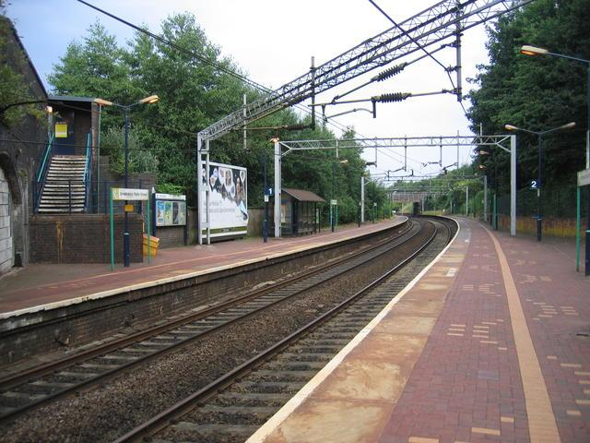

Currently, no bus stops serve this area of Brackley, so new bus stops will have to be made around the station. The car park will be relatively small but could be extended in future if capacity requires. 2 platforms will be in place at the station, but this could be doubled also if capacity requires. See the figure on the next page for context:

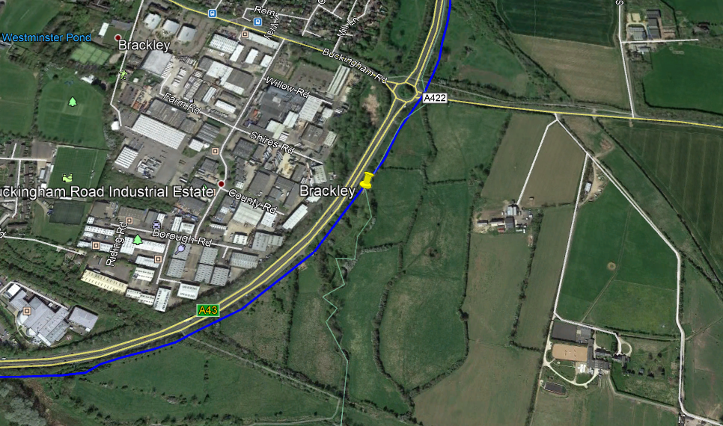

Brackley is growing at a record rate, and is bombarded by living accommodation, with terrible transport links. The SNL can change that with a brand-new railway line linking Brackley, once famous for its railways, back to the passenger network.

No special services will run as far as Brackley, so they will not make any extra stops, however all standard services on the Southern branch will stop at Brackley.

## 3j: Banbury

Banbury will be the Southern branches West terminus, where all services terminate/start from. Banbury is already a massive station, with a huge car park which is fit for capacity for years already, so the main upgrade to Banbury will only be 2 new platforms. It is quite a big job, but that is all that Banbury needs to accept this new capacity, as it is already capable of doing so.

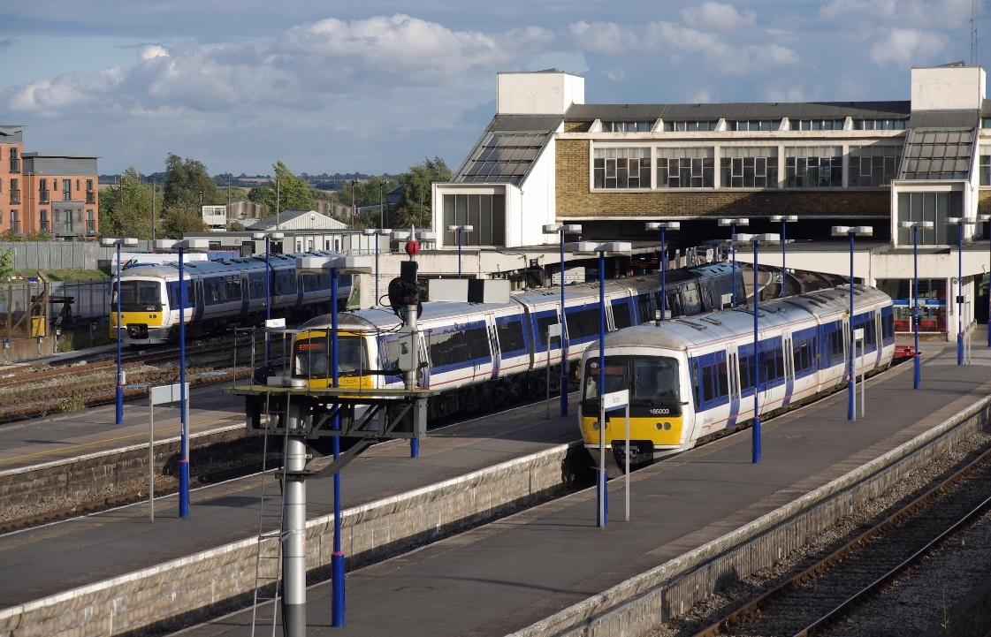



# Services/rolling stock

## 4a: Service frequency

All South Northants Link services will leave from Northampton Central, arrive at Banbury or Leamington Spa, then reverse, like a metro style system.

**Central Branch**

All services start and use the Central Branch, when arriving or leaving Northampton Central. All services on the Central branch stop at Northampton Parkway (excluding special services) and Weedon Interchange. Because of this, the Central branch has not got a specific service frequency, as its only task is to connect Northampton Central to the rest of the network.

**Northern Branch**

The Northern branch includes the stations of Weedon Interchange, Daventry, Southam and Leamington Spa. A service will run hourly on this line, leaving from Northampton Central and reversing at Leamington Spa, and stopping at all stations on the Central and Northern branch (excluding special services), with Southam as an exception, it will only get a 2-hourly service.

**Southern Branch**

The Southern branch includes the stations of Weedon Interchange, Towcester, South Northants Parkway, Brackley and Banbury. The line will get a half-hourly service leaving from Northampton Central and going back at Banbury. It will stop at Northampton Central, Parkway and Weedon Interchange on the Central branch, then switches to the Southern branch to stop at Towcester, Brackley and Banbury where it terminates (this does not include special services). South Northants Parkway will get a 2-hourly service, and of course, race special services will terminate here and reverse to Northampton Central.

## 4b: Rolling stock

New rolling stock can be released by manufacturers anytime, so it is hard to know what is best for the future, however, now, the most likely option for this line is the following:

**Non-electrified**

Class 230 Battery EMU/DMU. This option is best, as it is already in operation on other London Northwestern Railway branch lines, such as the Marston Vale Line in Bedfordshire/Buckinghamshire. They have worked the line for more than a few years and are still in operation today. They can be ordered as a Diesel Multiple Unit, or Battery Electric Multiple Unit, which charges on overhead lines at stations with overhead power.

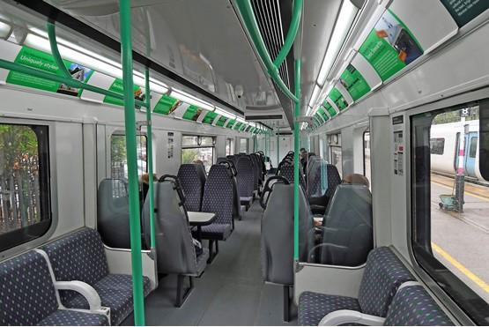

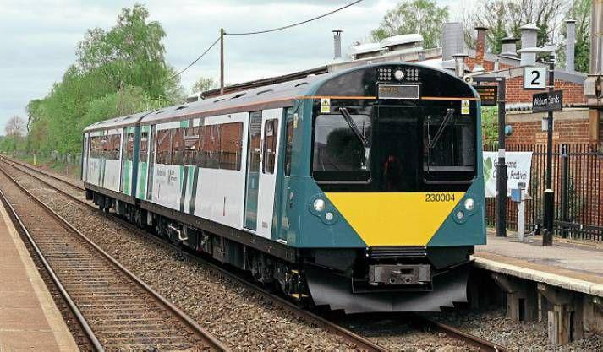

**Electrified**

If the line turns out to be electrified with overhead power, this a big plus for the route. It would mean we could run direct services along the line to London, Birmingham or even Crewe if capacity allows it. However, what we are talking about here is rolling stock. By the time this line is approved (if ever), Aventra’s will be running on the West Coast Main Line and other London Northwestern Railway branch lines, they are due to come into operation next year (2021). Because of this, LNWR will have many spare Class 350’s, which we could use on this line (or just use their Aventra’s!)

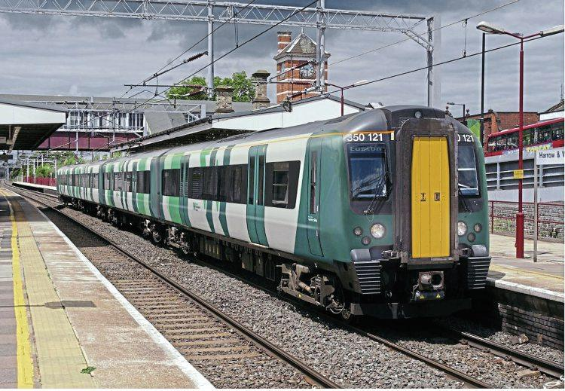

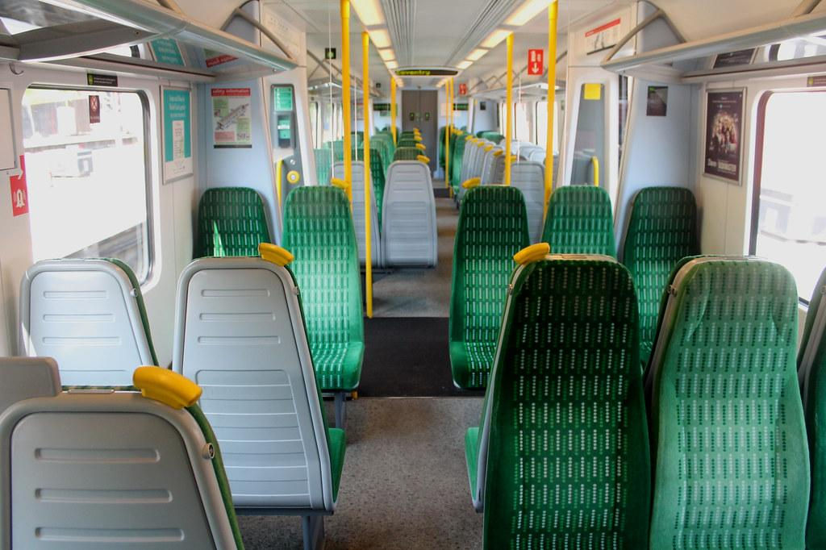

## 4c: Special services

As we all know, Silverstone Circuit is one of the busiest and most popular race circuits in the country and used by the likes of F1 and GB Racing. I am not a motorsport kind of guy, but I know the circuit needs a better link. It has not even got a bus route. The perfect way to solve this is South Northants Parkway, which will get special services on “race-days”, with longer trains that can pack more people. Trains will run to South Northants Parkway via Northampton Central, stopping at Weedon Interchange and Towcester on the way, then reversing back at South Northants Parkway to Central, to do their standard duties via the timetable.

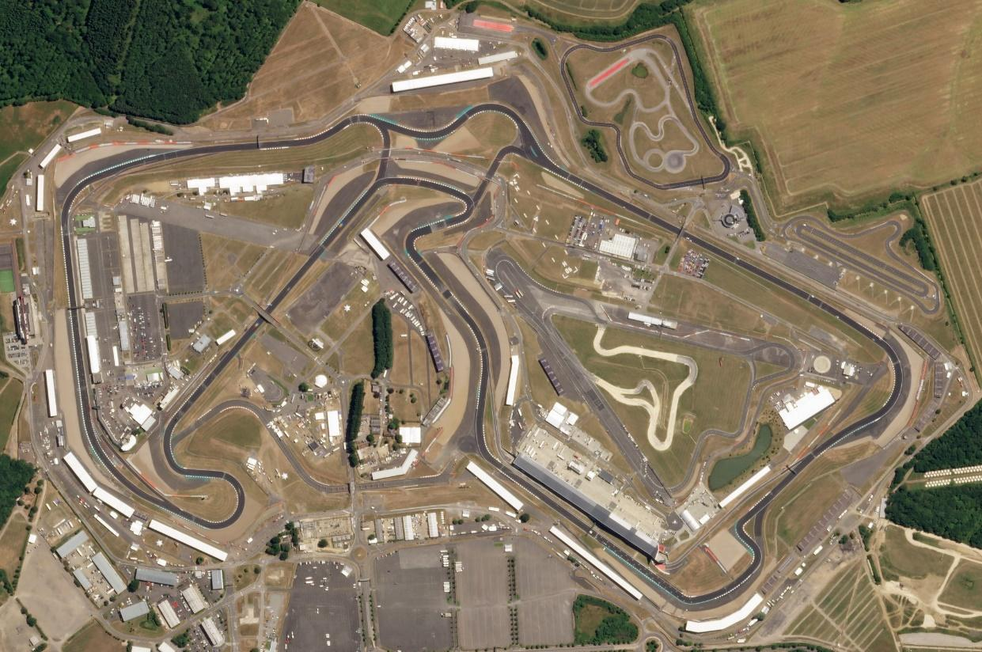

## 

## 4d: Request stops

Request stops may be implemented on the South Northants Link Line, to allow access to the line from smaller villages and hamlets without introducing congestion. Many request stops exist in England, Scotland and Wales including Wootton Wawen, Bynea, Kirkby-in-Furness and Duncraig. On this line, stations such as Braunston and Dunchurch stations could be opened as requests, allowing trains to only stop if someone wants them to, therefore not clogging up the line as much. On our Google Earth file, available on our website, we have created a layer with locations of potential request stop stations. Obviously not all of them would be implemented, as around 15 are on our list.

However, instead of holding your arm out to stop a fast-moving electric train, buttons/tablets will be introduced at the request stop station for people to click to send a message to the signaller/driver to stop their train, the next one that would be arriving at the station on that platform. (1 on each platform, 2 in total)

If someone wants to stop at a request stop during their journey, they can let the conductor on the service know to let the driver know to stop the train. Alternatively, we could develop an app to allow passengers on the service to send a message to the conductor/driver for them to stop the train at a specific stop. This has not ever been tried on an electric line in the UK, which is why a button would be implemented instead of the driver having to slow the train down on approach to the station, and so they have longer notice.

Daventry/Towcester North/South/East/West/Parkway request stops could be built for better access to the line throughout the large town (same for Banbury, Leamington Spa and Northampton)

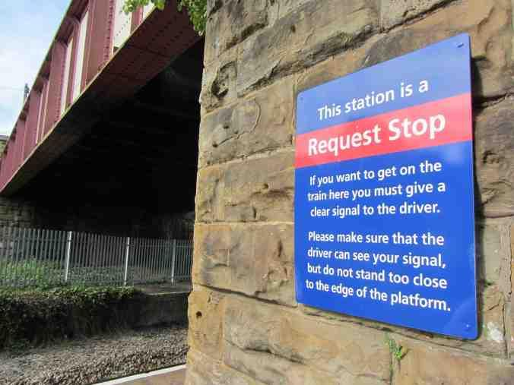



# Environment

## 5a: Getting cars off the road

81% of people in the East Midlands have a car permanently available in their household and use it often, according to Statista Research Department. Out of this 81%, more than 6 billion miles were driven on Northamptonshire roads (DfT RTS.) We need to make these numbers lower, and to do that, more people could adopt rail as their primary way of travelling daily. However, the people of Northamptonshire are limited in doing that with the small number of railway stations in the county (six), and no links to their local town/village.

We can change that for South Northamptonshire and Daventry District residents by giving them a link to this fantastic infrastructure, and get them to use cars less often, in replacement of energy-efficient, electric rail.

If this line is built, less people will rely on their cars for their daily commute. I know a lot of people that live in Weedon and work in Daventry, even close family, that would be happy to give up the car in replacement for a train/bus commute. This is also the same for people who live in Silverstone and work in Towcester, or even people who live in wonderful Leamington Spa and work in Northampton, who cannot even get there via rail without going up to Coventry and changing onto one of the slowest electric trains in the UK.

## 5b: The UK net-zero 2050 promise

If the UK wants to achieve net-zero by 2050, then they will have to make Northamptonshire an independent state, as we cannot get people out of cars without a replacement! Buses in Northamptonshire are quite bad, compared to other counties, with just the standard Stagecoach bus running. A great replacement would be sustainable and eco-friendly rail, connecting South Northants and Daventry to the rest of the county, and nationwide rail network.

Cars are admittedly bad for the environment, but unfortunately, the East Midlands and most of the North rely on them for their daily commute. The British Government can change this by investing more in rail infrastructure such as this project, to help us rely on sustainable rail instead! The entire network will run on electricity, using no diesel on the link at all! (excluding certain types of freight)

